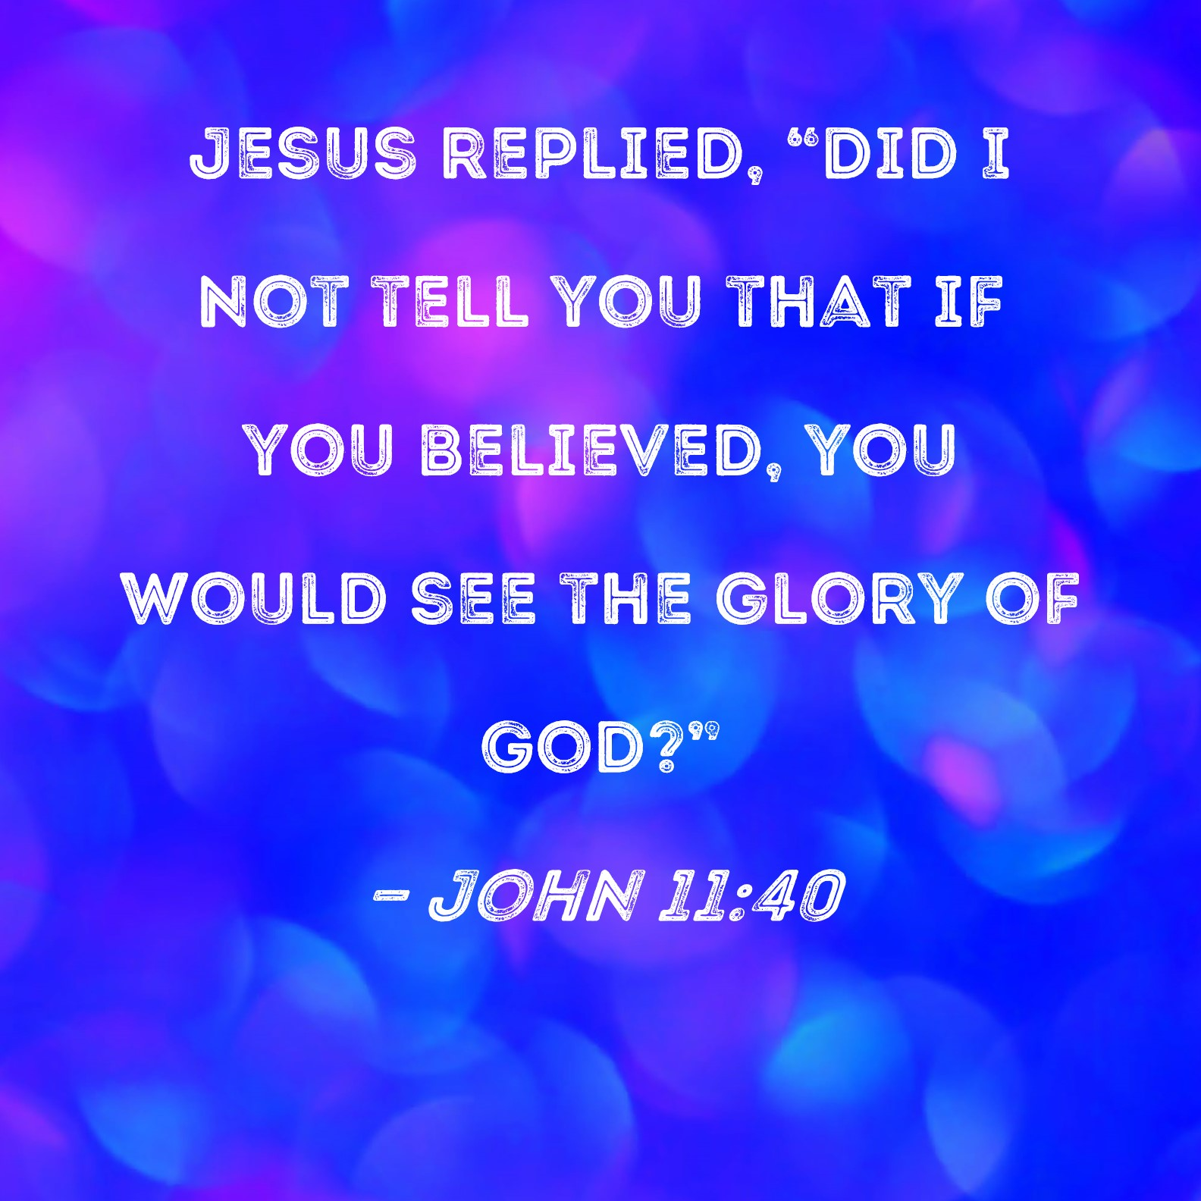

The Glory of God

Writer: John Tanner

The Glory of God

What is it and what does it mean to me?

The Third “World Prayer Assembly” will meet in Perth, Australia in the first week of October 2023. In the lead up to this assembly, believers from around Australia have been praying and fasting. There is a sense among the believers that a break-through is desperately needed to bring our sin-sick world back to the Living God.

The believers will come together to pray for “A Wave of Glory” to sweep across Australia and the world.

- What are they expecting to happen?
- What do we mean by “the Glory of God?”
- Are they correct in praying for a wave of glory and not an empowered Gospel?
- Is the glory of God just for Him or does it have something that is essential to all humanity?

When you begin to think about it, there are so many questions you could ask about the glory of God. In fact, you could never come to the end of the number of questions about God’s glory because it is infinite and somehow beyond our complete comprehension.

As I have followed my daily Bible reading plan over the past three months, I have taken special note whenever I have found a verse or a passage about the Glory of God. How many verses are there in all of the Bible? Too many for anyone to count! But I truly hope that what I have found will help you as it has helped me in my understanding of God and His ways with us.

What is “the Glory of God?”

My close friend, Rev Roy Funu will be leading a delegation of twenty-five people, mainly Melanesians, to the Assembly in Perth. Roy described the “glory of God” in his daily devotional for all the prayer warriors as:
- Brightness or splendour
- Great power and strength
- Majesty and honour

These descriptions of God provide us with a great beginning point. They reminded me of words written in 1 Timothy 6:15,16 by the Apostle Paul to young Timothy.

God, the blessed and only Ruler, the King of Kings and Lord of Lords,
who alone is immortal and who lives in unapproachable light, whom
no one can see. To Him be honour and might forever. Amen!

The glory of God comes from the fact that He is so different from everyone else. There is humanity – struggling, warring, sinning, dying, and then there is God. He is Other than us. He is the supreme Ruler over all creation and all Kings and Presidents. We die, but He is immortal! Because of the shame of our many failures and sin, we prefer to hide in the darkness. But He has nothing to hide! He is the light! He is so pure, so holy, so radiant that the light precedes Him and hides Him from sinful eyes in case we are incinerated. He alone is worthy of the honour of all creation and His all-conquering power ensures that He will reign over all things for ever!

- God is forever shining! He is holy. He is absolutely pure. And light reveals itself!

The glory of God is seen in part in His shining in Heaven and occasionally in the world. The Apostle John said, “God is light and in Him is no darkness at all.”(1 John 1:5)

- When God wished to catch the attention of Moses in the desert, He caused a shrub to burn with a radiant light that did not consume the bush. Shining glory – indicating God’s nearness! (Exodus 3:1-5)

- When God liberated the Israelis from their slavery in Egypt, He led them personally by means of a pillar of cloud by day and a pillar of fire by night - sign of His nearness and direction. (Exodus 40:38)

- When Moses had constructed the Tabernacle in the desert and the Ark of the Covenant had been placed within the Holy of Holies, the fire of the glory of God remained above the mercy seat! This phenomenon was a sign of God’s forgiveness and nearness and a for-runner of the cross. (Exodus 40:34,35)

- Ezekiel tells us about how he witnessed the glory of God re-enter the holy of Holies once the Temple had been rebuilt. (Ezekiel 43:1-5)

There are many other examples of the light of God’s glory shining to reveal that He is near, yet at the same time He is so holy that sinful eyes cannot see Him through the shining glory!

I will never forget the night when 1500 of us were worshipping in a village Church in east Malaita. We had three kerosene lights to light the whole building. By the end of the message only one light remained illuminated – the one above the preacher. We were encouraged to pray in the semi-darkness. As we prayed, it was as though a strong searchlight beam suddenly shone on each of us and filled the building. There was much conviction and confession of sin because each of us felt certain that God’s light was shining deep within our hearts revealing sins that should not be there. God was near and He was revealing Himself! After much confession there came a release and a wonderful sense of forgiveness. Then our worship really came alive and we praised the Saviour who had taken our sins in His own body on the cross!

All this is part of the Glory of God! Immortal, invisible, God-only wise!

There was a day when Moses asked to see the glory of God. I imagine that it was because of what we have just considered that God answered Moses,
But God said, “you cannot see my face, for no one may see me and live… There is a place near me where you may stand on a rock. When my glory passes by, I will put you in a cleft in the rock and cover you with my hand until, I have passed by. Then I will remove my hand and you will see my back; but my face must not be seen.” Exodus 33:20-23

No sinful human being, not even Moses, can see God’s face and live. His glory is so great! But one day, if we believe, we shall see Him face to face!

But in this God-encounter, we learn something more about God’s glory. The lesson is so important that it can be life-changing for us. We have already learned that God’s glory causes Him to outshine everyone and everything in all of creation. His power is supreme and His glory is radiant! Now, as the story continues the shining God describes the glory that is hidden in the light! The Lord told Moses (18),
“I will cause all my goodness to pass in front of you, and I will proclaim my name, the Lord, in your presence. I will have mercy on whom I will have mercy, and I will have compassion on whom I will have compassion.”

- God’s glory is seen in His intrinsic goodness!

Paul wrote, “There is none good, no not one!” But Paul was writing about humanity. God’s goodness is on permanent display. It is linked eternally with His Name. God is revealed in the Old Testament by the Name, “Jehovah,” in the older translations, and by “Yahweh” in the more modern translations. The Jews reverenced the Name of God so highly that they could say it. Instead, we read “the Lord” in many translations. The spelling of the Name of God is not important but the meaning is because it reveals the glory of God. God told Moses, “You want to see my glory – here it is – Yahweh!” No one else can ever say this Name. It means, “I will be what I will be!” He is the only self-determining Being!
No one and nothing can change Him from what He wants to be. What is God essentially in His person?

- He is a merciful God – I will have mercy on whom I will have mercy.”
- He is a compassionate God – I will have compassion on whom I will have compassion.

No one can stop Yahweh from showing mercy; no one can hinder Yahweh from having compassion. He loves everyone! God’s goodness is a part of His glory! God’s Name convinces us that He will always be good to all.

So far, we have come to understand that the Glory of God can be seen in His “otherness;” in His Name, and in His constant goodness which reflects His character.

- God’s glory is always seen in His actions.

God’s actions in history are the result of His character – He is good. He is merciful. He is compassionate. He is wonderful! And so, all God’s actions reveal His glory.
- God entrusted the first humans to rule over the earth. He came down daily in the cool of the evening to fellowship with them. But they listened to the tempter and deliberately disobeyed God! Here was the very pinnacle of God’s creation in rebellion against Him. Yet God did not destroy them and start over. He forgave them and absorbed the pain of their sin into His own heart. In due time God would pay for that sin Himself in the death of His only beloved Son on a Roman cross.
- When the descendants of Abraham were slaves in Egypt it was God who came down to deliver them. He chose their leader, Moses. God sent the many plagues upon Egypt to prepare the people for the exodus of the Israelis. God opened the way through the Red Sea to allow His people to exit safely, then closed the waters to destroy the pursuing Egyptians.
- When it seemed that the whole nation would become worshippers of the foreign god Baal, it was God who caused His fire to reign down from Heaven to consume not only the sacrifice but also the rocks that formed the crude altar.

All of God’s actions, from the creation onwards, show us that He is the only true God. He reigns! He will always act according to His perfect character in goodness!

Are you thinking, “Well, that is good to know about God but here I am stuck in a busy, imperfect world struggling to understand what my life is about and how I can live it!”

God is compassionate and merciful. He wants to help you to find meaning and direction for your life. In fact, it was because God was determined to be loving and compassionate that He created the human race and imparted to us some of His glory so that we could rule in His place over our own world.

The Glory of God imparted to the Human Race

When we go back to the beginning, we discover God at the very peak of creation saying,
Let us make man in our image, in our likeness and let them rule over all the other creatures… So, God created humans in His own image…male and female, He created them and said, “Subdue the earth and rule over it.” Genesis 1:26-27.

Human beings were created in the image and likeness of God and given the power and the authority to manage all of creation on planet earth. They were to be God’s representatives.

What does it mean that God created humans in His own image?

We are flesh and blood but He is Spirit. We are not the same! To be created in the image of God in the Hebrew language means that what has been created is so similar to the Creator that you cannot tell the difference between the two. Obviously, the image of God in humans relates to our capacity to think, reason, plan, love, forgive, invent and discover new things and to become true spiritual beings. Many of these qualities are necessary if we are to properly represent the Creator in “ruling over His creation.”

- Humans were to rule over the earth. The highest heavens belong to the Lord; but the earth He has given to humans. (Psalm 115:16) We are responsible for life on our planet. If we allow it to become a polluted, inhabitable, inhospitable place then we have failed in our God-given mandate.

- Humans have been crowned with glory and honour. You made him a little lower than the heavenly beings; and crowned him with glory and honour. (Psalm 8:5) Human beings sit just below the Angels and above all of the rest of the animal world. God has imparted to us some of His own glory to enable us to rule under Him.

- Humans were to represent God’s authority on earth. You made him ruler of the works of your hands; You have placed everything under his feet. (Psalm 8:6). Everything is under our feet! We are responsible for everything and everyone. We are to rule as Yahweh rules – in goodness, compassion and mercy.

What an awesome responsibility God has entrusted to the human race!

How well have we handled the tiny part of God’s glory that He has bestowed on us?

The Glory of God wasted by the Human Race

God crowned humans with glory and honour so that we could represent Him in our stewardship of the earth. How well have we done?

Paul answers the question in Romans Chapter 3:23 –

For all have sinned and fall short of the glory of God and are justified
freely by His grace through the redemption that came through Christ Jesus.

Let us consider an example from our own school days.

When the exam has been completed comparing our performance with the Glory of God, the school master will have some glum news for us all. Some of us did very badly – only one or two out of ten. Those who had tried harder scored five or six out of ten. But, sorry class – no one even came close to scoring ten out of ten. We have all fallen short of the glory of God! We did not shine! Our goodness was mixed with badness! Our love, our compassion and our mercy fell far too short of what was needed! Even the best of us are sinners when compared with the glory of God!

Is it any wonder that our societies are crumbling and our families are becoming dysfunctional. Corruption is rife in the political areas and big business in the main is self-serving. Violent crime is threatening all of us in the place that was once our safe place – our homes. The world is closer to war than it has been in decades. And as Paul wrote, “the whole of creation is groaning awaiting the day of redemption.” (Romans 8:22) We have all fallen short of the glory of God!

Is our humanity now totally bereft of the glory of God? No - something of the image of God remains! As James says, “With the tongue we praise our Lord and Father, and with it we curse men who have been made in God’s likeness.” (James 3:9) Despite our fallenness, humans retain the capacity to reason, plan, invent, discover, worship and to be wonderfully self-less, compassionate and kind. There is still hope!

And Yahweh is Yahweh! He is compassionate and merciful. We who have fallen far short of His glory can be justified freely by His grace through the redemption that came through Jesus Christ! (Romans 3:23) This is our only hope!

The Glory of God Revealed again by Jesus Christ

In the past God spoke to our ancestors by the prophets at many times and in various ways, (2) but in these last days He has spoken to us by His Son, whom He appointed heir of all things, and through whom He also made the universe; (3) The Son is the radiance of God’s glory, and the express image of His person, and sustaining all things by His powerful word. After He had provided purification for our sins, He sat down on the right hand of the Majesty in Heaven. (Hebrews 1:1-3)

The Lord Jesus is God’s ultimate and most perfect message to all humans. He shone with God’s heavenly brightness and He expressed God’s divine characteristics. Jesus was the radiance of God’s glory and the express image of God’s Person. The glory has not been lost! It was returned to the earth by Jesus the babe of Bethlehem who lived a sinless life.

His glory was not hidden from human eyes. Listen to the Apostle John’s testimony.

The Word became flesh and made His dwelling among us. We have seen
His glory, the glory of the One and Only, who came from the Father,
full of grace and truth! (John 1:14)

It is time to ask, “What did the early followers of Jesus see when they beheld His glory?

What was it that prompted the writer to the Hebrew believers to say, “Jesus is the radiance of God’s glory and the express image of His person.?”

- Jesus’ face shone like the sun and His clothes became as white as the light.

Towards the very end of His earthly life, Jesus took Peter, James and John mountain climbing. When they were quite alone on the mountain, “Jesus was transfigured before them.” (Matt.17:2) The Greek word translated here by the English word “transfigured” occurs only three times in the New Testament. Its meaning is that the inner reality shines out. In other words, the three disciples literally saw the godlikeness or glory of Jesus revealed. That this display of the glory of Jesus is confirmed by God’s words that follow. “This is my Son whom I love; with Him I am well pleased. Listen to Him!” (Matt.17:5) Here in this one passage we have two expressions of the glory of God in Jesus Christ:
- “The radiance of God’s glory” – “Jesus was transfigured before them.”
- “The express image of God’s person” – “This my Son whom I love.”

This dearly loved Son of the Father God, made in God’s own image, the radiance of God’s glory, was the same person that we corrupt humans rejected. We despised Him. We cruelly mocked and whipped Him. We unjustly tried and crucified Him because He claimed to be the Son of God! We joined our voices with the violent crowd, “His blood be on us and on our children!” (Matt.27:25)

- Jesus’ glory was seen in His intrinsic goodness.

It may seem strange to you, but in the battered body of our Saviour on that cruel cross we have one of the greatest examples of the glory of God in Jesus. God’s glory is revealed in His goodness. His loving nature means that He is merciful and compassionate. God’s Name declares His uniqueness – He will be whatever He wills to be. No one can change Him. No one can force Him to change His plans because they are always wise and perfect.

So, when the first humans rebelled against God’s loving heart and plans, they created a gap between themselves and Holy God which no one could bridge. This was not a surprise to God! He is all-knowing! So, when He created the first humans, He did so knowing that they would rebel and that it would be necessary for Him to endure thousands of years of separation from them until His Son could come as the second glorious Man and die to pay the price for their rebellion and restitution.

The cross reveals the glory of Jesus in His goodness and mercy, and in a victory that will be celebrated for ever!

- Jesus’ glory was seen in His life, words and actions

Jesus and His Father always operated as one, such was the perfection of their loving relationship. Jesus claimed that the words that He spoke were the Father’s words. Jesus also claimed that the deeds that He performed were the Father’s deeds. He was totally committed to fulfilling the Father’s plan for the redemption of humanity. Jesus moved through every day with His life in total accord with His Father God. This is the glory of the Son of Man!

Remember that it was the disciple John who wrote “and we have seen His glory, the glory of the One and Only, who came from the Father, full of grace and truth.” (John 1:14) John was one of three disciples who witnessed the transfiguration of Jesus when the glory of God shone out from Jesus body. But God’s glory was on display in the daily life of Jesus continually as He lived in unity with His Father.

One day, following an attempt by the Jews to stone Jesus for blasphemy, Jesus said, “I and the Father are one!” (John 10:30) Jesus perceived that the Jews did not believe Him so He added, “Do not believe me unless I do what my Father does. But if I do it, even though you do not believe me, believe the miracles, that you may know and understand that the Father is in me, and I am in the Father!” (John 10:37,38) The glory of Jesus was evident through the demonstration that every word, prayer, miracle and encounter was the product of His perfect union with God the Father. Even our salvation is the result of the Father drawing people to Jesus and Jesus holding them safe forever in His hands. (John 6:36-40)

Jesus said, “I am the way, the truth and the life. No one comes to the Father except through me. If you really knew me you would know my Father as well…” (John 14:6)
Evidently Philip did not understand because he asked Jesus, “Lord, show us the Father and that will be enough for us.” (v8) Jesus replied, “Anyone who has seen me has seen the Father. Don’t you believe that I am in the Father and the Father is in me? The words that I say to you are not just my own. Rather it is the Father living in me who is doing His work. Believe me when I say that I am in the Father and the Father is in me; or at least believe on the evidence of the miracles themselves. (v9-11)

When Jesus stood with Martha outside the grave of the long dead Lazarus He said to her, “I am the resurrection and the life. Whoever believes in me will live even though they die!” (John 11:25) Then a little later, Jesus said to Martha, “Did I not tell you that if you believed, you would see the glory of God…Then Jesus commanded Lazarus to return to life and come forth from his grave…, and the dead man came out!” (v40-44)

The glory of our dear Lord Jesus is seen always in His unbroken fellowship with His Father which enabled the Father to work through His Son unhindered. And in all of Jesus’ teaching and miraculous deeds we see proof of the goodness, love and graciousness of God the Father.

Jesus is the radiance of God’s glory and the express image of God’s person. All praise and thanks be to Him!

At the beginning I posed the question, “Is the subject of God’s glory all to do with God or does it have some important relevance to me today?” It is time to reveal the answer to that question.

The Glory Restored to Humanity

When He was just hours away from His trial and death, Jesus prayed the beautiful prayer that is recorded for us in John Chapter 17. His overwhelming desire is for the glory of God! Listen reverently, “Father the time has come. Glorify your Son, that your Son may glorify you. For you granted Him authority over all people that He might give eternal life to all those you have given Him!” (v1,2) In the cross and in the great salvation that has come through Jesus to millions of believers both the Father and the Son have received great glory and continue to do so.

- You and I are the beneficiaries of the glorious work of God via the cross of Jesus!

One day when we meet Jesus face to face in the glorious presence of Father God, we will be able to express our gratitude to Him through lips that are no longer tainted by sin! What a wonderful day that will be! We will join in singing, “Worthy, worthy is the Lamb that was slain for us!”

Sadly, many believers think that this is all there is to their salvation. They continue to live as they did before Jesus saved them in a purposeless and mundane existence. How frustrating and boring! There is much more to our story!

For those believers in this category I want to ask you a personal question. “What have you done with the glory that God has entrusted to you?” You see, at the conclusion of Jesus’ prayer recorded in John 17 Jesus makes an astonishing statement. He tells the Father, “I have given them the glory that you gave me, that they may be one as we are one: I in them and you in me. May they be brought to complete unity to let the world know that you sent me and have loved them even as you have loved me.” (vs 22,23)

We learned earlier that part of the glory of Christ lay in the fact that he lived His earthly life in complete unity with His Father. He revealed the words, the miracles and the love of His glorious Father. Now we learn that He imparted God’s glory to His followers. Significantly for us and all future followers, we should live in this same unity with the Godhead and with other believers. Our “complete unity” is a sign that Jesus is the legitimate Saviour of the world and representative of the glorious Father in Heaven.

It is evident to everyone that believers everywhere have not yet achieved this level of unity. We must allow the Glory to work further in us to verify the authenticity and mission of the Lord Jesus. We need to experience more of the glory of God in Christ!

How can this occur?

Earlier, when we were thinking about the Lord Jesus being transfigured on the mountain top, I mentioned that the Greek word translated there as “transfigured” is used in two other places in the New Testament and translated as “transformed.” It is time to discover how Gods wants us to share His glory!

- God wants us to be more than believers, He wants “living Sacrifices.”

There is a pathway that leads to believers learning to display something of the glory of God in our daily lives. It begins with the moment that God forgives our sins and enters into our lives through the indwelling Holy Spirit. The second step, to be made in view of God’s mercies to us, is to “stop being conformed,” and to be “transformed.” (Romans 12:1,2) Paul exhorts all believers to “stop being conformed to the patterns of the world.” The Greek word here means, literally to wear a mask. The Greek word is like our word “hypocrite.” In Greek culture, the actors in a play (called hypocrites) all wore masks depicting the characters they represented. So, Paul was exhorting the believers to be real to their faith and not to copy the practices and beliefs of the surrounding culture. If the believer copied the world’s ways, then they would be acting as a hypocrite. We could truly use the same word relating to Christians today who live so much like the world that they are lacking in the “salt and light” that Jesus gives. Many times, the world calls Christians “hypocrites” and shamefully it is true!

Paul exhorts us to do the opposite. Through the renewing of our minds, we are to be “transformed” so that we can know and approve God’s will and do it.

How are our minds renewed to know God’s will and do it as Jesus did?

- God is re-investing His glory in believers who desire to be transformed

To answer our question, we need to turn to 2 Corinthians 3: 17,18.

In the surrounding verses, Paul is discussing the glory surrounding the giving of the Old Covenant through Moses and the surpassing glory that accompanies the ministry of the New Covenant established by the Lord Jesus on the cross. So, in a few short verses, Paul encompasses many, many years of history from Moses to Jesus. Moses had to cover his face after meeting with God because for days it shone with God’s glory. This caused the people to be afraid and to turn away from any sight of a Holy God. But since Jesus came things have changed. Even though the eyes of many Jewish people remain veiled to the reality of God in Christ, believers are no longer afraid to approach God. Instead of fear, we now enjoy the freedom that belongs to the Spirit. And God intends that our faces should reflect the glory of the Lord.

As we faithfully study the Bible, listening for God’s instructions and sincerely seeking to meet with Jesus in our thought life, the Holy Spirit works in us. The transformation is not instantaneous – it is progressive. Notice that Paul says, “we are being transformed” and “with ever-increasing glory.” The transformation which is the work of the Holy Spirit, is both progressive and persistent - a life-long transformation to become more and more like Jesus for His glory!

Through faith in the Gospel, God returns His glory to human believers but it is only at the beginning stage. We must stop conforming and allow transforming to take place in our minds. As the Spirit leads us and we gaze every day at Jesus, we are being transformed into His likeness with ever increasing glory!

Oh, to be more and more like Jesus! To shine everywhere with the light of the glory of God in a world that so badly needs to know Him.

God is at work in us preparing us for the time when we will see His glory fully. In the meantime, He is at work in us by His Holy Spirit revealing an ever-increasing degree of His Glory!

Can we see His glory being manifested in humans everywhere?

The writer to the Hebrew believers quotes Psalm 8:5 “you crowned him with glory and honour” in chapter 2:6-8. There he reveals that the son of man in Psalm 8 is fulfilled in Jesus the Son of God and Son of Man. Remember that humans were originally meant to “rule” over the earth. “Is the true Son of Man now ruling with everything under His feet?” the writer asks. And he answers, “Not yet – we do not see the end yet, but we see Jesus who was made a little lower than the angels now crowned with glory and honour.”

The work of the great Yahweh God – “I am what I am,” and,“I will be what I will be” is almost complete. Jesus has been glorified in bringing many humans into the Kingdom. We are progressively revealing more and more of God’s glory as we become more like Jesus!

But right now, the future glory is certain, but it is also “not yet!”

If God graciously grants to us another wave of His glory before Jesus returns for His people to take them home it will be for His glory alone.

There will be no Christian celebrities involved. There will not be a focus on “our needs,” desperate as they are. It will be for God alone! It will make public His glory and the glory of Jesus His Son. Jesus will be the focus and His presence will be extraordinary. There will be no room left for sceptics or doubters. And whatever miracles occur will be to show God’s glory to all!

Then the words of the writer in Psalm 115:1 will become our words.

“Not to us, Oh Lord, not to us but to your Name be the glory, because of your love and faithfulness.”

