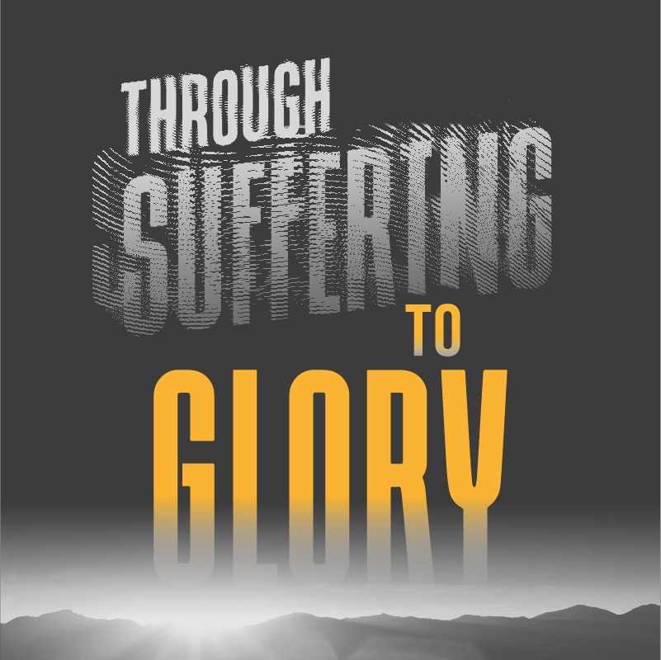

A Bible Study about life based on Romans Chapter 8

Writer: John Tanner

Suffering - who wants it?

Even our dear Lord Jesus, when faced with the horror of the cross prayed, “ If it is possible let this cup pass from me!” Nevertheless, He went to the cross, despising the shame, and brought great glory to God through making forgiveness and salvation available to all humankind.

Paul wrote, “I consider that our present sufferings are not worth comparing with the glory that will be revealed in us.” (Romans 8:18) One thing is certain. As we move closer to the end of this present age, believers will experience suffering - even those living in the comfort of the Western world! But this verse tells us that soon God will reveal His glory in us.

We know that God will be glorified in His Church when Jesus comes to take us to be with Him at the end of this present age. How wonderful that will be!

But the immediate context of this verse teaches us that God wants to reveal His glory in our lives even now as we endure suffering for His sake. We need to understand that our suffering and God’s glory are linked together in the same way as the two were inseparable in Christ on His cross.

There are more believers suffering today, partly because of their faith, than ever before. Persecution is common in many countries around the world. And, of course, there are other ways that we can encounter suffering. For example, through sickness or the loss of someone we love.

How can we shine for God’s glory when we enter into a time of suffering?

In my role as a Christian leader charged with the care of God’s people, I have found that an experience of suffering is one thing that challenges people’s faith and causes them to doubt God.

The story of the Sower and the soils reminds us that some tender plants died when “trouble came,” and some ceased to bear fruit because of the “cares and riches of the world.”

How can I experience suffering and be someone who reveals God’s glory at the same time?

Paul teaches us the secret in Romans Chapter 8 verses 28 to 39. In this well-known, but often misunderstood passage, Paul teaches us:

- Five Eternal Truths
- Five Great Affirmations, and
- Five Questions About God’s Unfailing Love

Many believers have a wrong understanding of Romans 8:28. They have interpreted it to mean that God sends bad experiences to them and calls the suffering “good.” Some believers have deserted the faith because they have felt deeply hurt through experiencing some form of suffering. What does the Bible say about suffering? I encourage you to make a careful study of each statement and ensure that you apply each one to your own life and situation. Here are some helpful truths courtesy of John Stott the famous English Bible teacher and pastor.

Five Eternal Truths

- God works in our lives. (From Romans 8:28) “We know that God works for the good of those who love Him.” For those who love God, He is ceaselessly, purposefully at work in our lives to fulfil His loving purpose for each of us.

- God works for the good of His people. “He works for the good of those who love Him.” Because God is good, all He does is good - ultimately designed to achieve our salvation.

- God works for our good in ALL things. “In all things God works for good.” All things includes suffering. In all things, God has a positive purpose in allowing them to happen to us. The purpose may not be evident to us at the time, but it is clearly understood by God.

- God works in all things for the good of those who love Him. “He works for the good of those who love Him.” God is primarily concerned with the blessing and transformation of those who have responded to His love in Christ. It is for their good that God works to
remake them into the image of Jesus, His own dear Son.

- God works for those who have been called according to His purpose. “Who have been called according to His purpose.” Our love for God indicates positively that God loved us first and demonstrated His love in sending Christ to provide for our salvation. When God sent His Son, He foreknew that we would reject Him and kill Him. But God persisted because His purpose was to bring many people from every nation and tribe into the Kingdom of God.

God’s purpose in working so ceaselessly in our lives is revealed in the following verses. The result of His working to fulfil His purpose is the ultimate revelation of His glory!

Five Great Affirmations

“For those God foreknew, He also predestined to be conformed to the likeness of His Son, that He might be the firstborn of many brothers. And those He predestined He also called; those He called He also justified; those He justified He also glorified.” (Ch 8:29,30)

- God has foreknowledge of everything. “Those God foreknew.” God knows everything that has ever happened. God knows everything that is happening today. And our amazing God knows everything that will happen in the future.

- God’s purpose is to make us into the likeness of Jesus. “Predestined to be conformed to the likeness of His Son.” God’s plan is not about whether we are “in” or “out” of His Kingdom, but about our destiny. Our destiny is to be people who reveal the likeness of Jesus in our lives to the praise of His glory.

- God’s call comes to us through the Gospel and our response reveals God’s will.
“Those He predestined He also called.” How glad should we be that someone took the trouble to share the Gospel with us so that we could hear the call of Jesus to “Come unto me all you who are weary and heavy burdened and I will give you rest!” When we responded to that call, God began His work in us of to make us into members of His family.

- Those who heed the call are justified by Faith. “Those He called
He also justified”
Because Jesus paid the penalty for the sins of the whole world on the cross, when I come to faith in Him, God regards me as “just-as-if-I had-never-sinned -” Justified freely by His grace!

- Those who respond will also suffer, but they will also share in
Christ’s glory.
“Those He justified He also glorified.” Carrying the cross every day of our Christian life is not optional, it is compulsory. Failure to do so means that we “cannot be Jesus’ disciple.” But suffering for Christ also has its own wonderful reward. “If we suffer for Him, we shall also share in His glory.”

So, when we are called upon to suffer for Christ’s sake, we can bring to our minds the five great truths. God is good. He is at work in us and in our circumstances to achieve His purpose. He is making us and shaping us for glory!

And when our minds are full of doubts and our spirits feel weak, we can take courage through Paul’s five great affirmations. God knows everything from the beginning to the end. Nothing ever takes Him by surprise! And He has called us so that He could give us His own family likeness - to be remade in the image of His Son Jesus. He will never remind us of our past failures but will instill in us a great confidence to endure the trials of life and to shine through them for the glory of Jesus!

Where does this confidence come from? It comes from God’s unfailing love!

Five Questions about God’s Unfailing Love.

What is it that we question when we encounter a time of intense suffering? It is God’s love! We may ask -

      - If God really truly loved me, would He allow me to experience this pain?
      - Would the God of love allow little children to suffer like this?
      - Is my faith strong enough to survive this suffering?
      - Will God carry me through this experience or will I fail?

In the light of the five great truths which Paul outlines in Chapter 8 and the five affirmations that flow on from these truths, Paul asks five questions that strengthen our faith in God’s unfailing love.

Paul begins with the words, “What, then, shall we say in response to this?” (verse 31)

- If God is for us, who can be against us? “He who did not spare His own Son, but gave Him up for us all - how will He not also, along with Him, graciously give us all things.” (v 32) God’s commitment to us is evidenced in the gift of Christ. What greater gift could He give us? What greater sacrifice could He possibly make to help us? Because this great God who has given His everything to us is for us, then surely there is nothing or no one greater than God who can win against us!

- Who will bring any charge against those whom God has chosen? (v 33) We are God’s well-loved chosen people. He has chosen us and saved us to be His family! Yes - once we were strangers and sinners before God, but now Christ has died for us. The price of our many sins has been paid by the blood of the Lamb of God. If God Himself will never accuse us, then no one else can ever bring a charge against us before His throne.

- Who can condemn us? “Christ Jesus who died is interceding for us.” (v34) Imagine for one moment that someone, perhaps it is Satan, appears before God’s throne to remind God of some sin or failure in your life that no one knows about. He is trying to condemn you! But hear this. In that same moment, Jesus, your Intercessor, leans across and reminds God the just Judge, “I died for this person; I was raised from the dead for this person; I was exalted to Heaven’s throne for this person, and I am their representative. My own righteousness covers them completely!” Hallelujah!

- Who shall separate us from the love of Christ? (v35) In the light of the answers to Paul’s first three questions, Paul asks us to consider if there is anything or anyone in all of creation that could break the eternal bond that exists between the Saviour and all those whom He has saved. He has promised that nothing will ever pluck us out of His eternal hands!

- We face death all day long: we are considered as sheep to be slaughtered; are we not vulnerable? “Shall trouble, or hardship, or persecution or nakedness or danger or sword?” (v35,36) No matter
how Satan tries to oppose us, we can be sure that we will see the glory of God revealed in us!

And so, with our full confidence in the love of God and the strong arm of the all-conquering Saviour who holds us, let us answer these questions as Paul did in verses 37 -39 -

“No, in all these things we are more than conquerors through Him who loved us. For I am convinced that neither death nor life, neither angels nor demons, neither the present nor the future, nor any powers, neither height nor depth, nor anything else in all creation, will be able to separate us from the love of God that is in Christ Jesus our Lord!!!” AMEN!

